**USER MANUAL**

LDAC Challenge: Dynamic Asset Management

**!** *This user manual can be used as a syllabus containing all the information for the case in a compact manner.* *First, a short summary of the case context and research goal is given. Then, the available datasets are introduced together with some extra resources. Lastly, some guidelines are given per day of the hackathon which can help with structuring the process of the challenge.*







1. Context

Participants will be challenged to combine dynamic vehicle data with static built environment data in order to trigger restrictions placed on the interaction between objects in those datasets. Additionally, newly gained information should be visualized in and be made accessible for the municipality of Utrecht so that it can aid in decision-making regarding logistic policies.

Main research question: How can we manage and visualize asset management data in the built environment using semantic web technology if some of this data is dynamic in time and location?

Sub question 1: How can semantic web technologies be used to manage assets if some of the data is dynamic in time and location?

Sub question 2: Is it possible to automatically restrict vehicles from entering certain zones in the city? What are the rules and requirements for this?

Sub question 3: How can SHACL be implemented in the information model behind the tooling? Is it possible to activate certain restrictions for trucks based on their time-stamp data?

Sub question 4: What are the steps needed for aligning different sets of data that originate from several sources, including written text-based documents?

Sub question 5: How can we visualize newly gained information that results from linking certain datasets? How can SPARQL and possibly OWL help with this and how does this work in a user-friendly manner?

Sub question 6: In case of inferencing new information using OWL, how does this work in combination with SHACL restrictions? Open world vs. closed world?

1. Datasets and supplementary resources

A description of all the available resources and datasets is given below. The actual data, files and other content can be found in the GitHub repository belonging to this challenge.

* 1. Static datasets

(given information that doesn’t dynamically changes depending on time or location)

* Open Vehicle database of the Dutch Vehicle Authority in RDF

These datasets can be exported, or accessed via API. On GitHub the exported RDF versions can be found.

1. A dataset containing several general properties of all registered and licensed vehicles in the Netherlands.

<https://opendata.rdw.nl/Voertuigen/Open-Data-RDW-Gekentekende_voertuigen/m9d7-ebf2>

1. A dataset containing several properties *regarding fuel and emissions* of all registered and licensed vehicles in the Netherlands.

<https://opendata.rdw.nl/Voertuigen/Open-Data-RDW-Gekentekende_voertuigen_brandstof/8ys7-d773>

* Overview public camera’s in the city center + restrictions in JSON format

This dataset shows the public camera’s that can register vehicle information by either reading a license plate or by receiving dynamic information sent through by their integrated navigation system. Their properties can be viewed on this map:

<https://gu-geo.maps.arcgis.com/apps/webappviewer/index.html?id=4c5846a184fa4ea0b75505c39f692ea0>

These camera’s, registered by ID’s and their coordinates are also part of the following dataset, **which contains geo-object information about restrictive objects in the city.** This dataset is called ‘Vehicle restrictions and camera locations.json’.

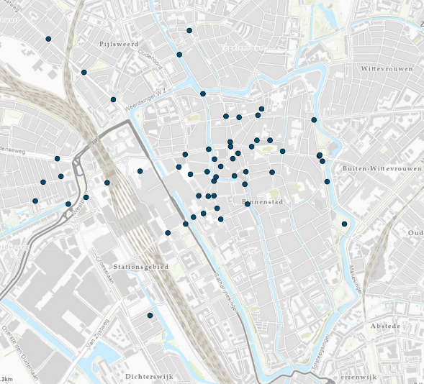

Figure : Public camera's present in the city center of Utrecht

* 1. Dynamic datasets
* Registered timestamp event data by city camera’s in RDF

In the file ‘event timestamp data.ttl’ several events are captured by camera’s. These events describe information about the arrival of a commercial vehicle and contain several properties such as an xsd:dateTime, loaded weight inside the vehicle and license plate information.

* Geo-data of truck locations sent by internal GPS system in GML
  + - Set met punten van actuele stand (paar snap shots) gekoppeld aan voertuigen (kenteken) *GML whatever er uit QGIS komt***Ellen**
  1. Supplementary resources
* Textual restrictions for logistic vehicles stated by Utrecht municipality

Taken from the (unfortunately only in Dutch) website of the municipality of Utrecht, a list of restrictions is available below that potentially impact routing of vehicles in the city.

1. On streets with canals, there is a restriction that prohibits vehicles from entering that are wider than 2,2 m.
2. 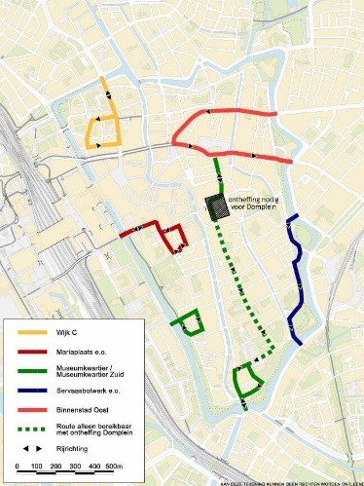There are certain routes in the city that are designated for loading and unloading. They are plotted out on the figure below. See <https://www.utrecht.nl/fileadmin/_processed_/9/2/csm_routes-goederenvervoer-binnenstad_93faf398e8.jpg> for a bigger figure.

* Restrictions for vehicles concerning environmental zones

This map indicates the environmental zone present in Utrecht. The map can be viewed on: <https://utrechtmilieu.nl/milieuzone/>.

**!** *This is a so called ‘purple zone’ where trucks with fuel type = diesel must have an emission class of 6 or higher. Otherwise they are prohibited in the zone indicated below.*

Figure : Area in the Utrecht city center that indicates a restriction for the emission class of a vehicle. This area is 'purple' which indicates commercial trucks must have an emission class of at least 6.

1. Challenge guidelines

There is of course no right or wrong method for taking on this challenge and everybody is completely free to design their own process which leads to answering the main research question. Still, to give some direction to hold on during these three hackathon days, you’ll find some guidelines to follow that already break up the problem in two smaller parts. These two smaller challenges are aligned as much as possible to the topics of the lectures that will be given in the mornings of the summer school. The two sub-challenges give an idea of the direction you could go in with figuring out your final prototype or solution to present at the end of the summer school.

* 1. Sub-challenge 1: Event-data registered by camera’s in the city

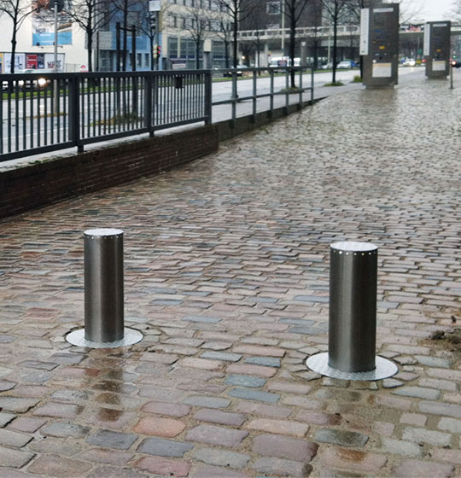Figure 1 shows the camera’s that are present in the city. These camera’s are connected to so called ‘bollards’ such as shown in the figure on the right. Now, imagine a truck approaching the camera, the camera reads the license plate and via the navigation system inside the truck, it can also capture essential live information on certain properties of the vehicle. Based on this information, the camera can give a signal to the bollard to go down, giving the vehicle access to continue its route, or not.

How can we use linked data principles to model this system? Which restrictions are needed to provide the camera with enough information to make a go/no go decision?

* 1. Sub-challenge 2: Restrictions based on geometric data

Figure 2 shows a map of the city of Utrecht with highlighted planes indicating certain environmental zones that restrict vehicles from entering based on their registered emission class. On Gitub, a GML file is available showing snapshots in the form of points on a map, representing the current locations of trucks following a certain route. When the vehicle enters the environmental zone, and it does not comply with the regulations defined by this zone, a fine should be generated and send to the municipal administration office for further processing.

Using linked data principles, how can we model this system? What are difficulties when a geometrical component that is changing through time is introduced? How can we handle this?